Logo%20Main%20200

**Boston University**

**Electrical & Computer Engineering**

**EC464 Capstone Senior Design Project**

User's Manual

Sweet City



Submitted to

National Grid Sustainability Hub

912 Main St. Worcester, MA 01610

(774) 239-7587

[worcestersustainabilityhub@nationalgrid.com](mailto:worcestersustainabilityhub@nationalgrid.com)

by

Team # 20

Sweet City

Team Members

Jessica Cadreau jcadreau@bu.edu

Jennifer Fong jkfong@bu.edu

Cameron Graves cagraves@bu.edu

Makenna Hart hartm04@bu.edu

Steven Li listeven@bu.edu

:

Submitted: April 7, 2017

#### Sweet City

#### Table of Contents

Sweet City 2

Table of Contents 2

**Executive Summary** **3**

**Introduction** **4**

**System Overview and Installation** **5**

Overview block diagram 5

User interface. 5

Physical description 7

Installation, setup, and support 7

**Operation of the Project** **8**

Operating Mode 1: Normal Operation 8

Safety Issues 9

**Technical Background** **10**

**Cost Breakdown** **14**

**Appendices** **16**

Appendix A - Specifications 16

Appendix B – Team Information 17

# 

# 

# 

# Executive Summary

Currently, many individuals are unaware of the importance of clean energy technologies. As of right now, our primary energy source is fossil fuel. However, due to greenhouse gas emissions, a decreasing amount of resources, and a declining cost efficiency, fossil fuels are negatively impacting the planet. Our goal is to increase awareness on this issue through interactive demonstrations.

The final product consists of solar, wind, energy efficiency, and smart grid modules. These four modules are encompassed in an interactive educational exhibit modeled around the city of Boston. The overall exhibit serves to educate individuals on energy technologies as well as National Grid’s Smart Grid pilot program. This is accomplished through displaying power generation and consumption values on LCD screens.

Each module approaches clean energy or energy efficiency differently. The solar and wind modules generate power and drive visual loads. The power generated will also be displayed on an LCD screen so users are able to easily understand the concepts of power generation. The energy efficiency module compares power consumption for LEDs and incandescent light bulbs. The power consumed by each bulb type is displayed on the module’s screen. The Smart Grid module depicts National Grid’s Smart Grid pilot program. It simulates a blackout and shows the company’s quick response. The response time is then displayed on an LCD screen. A second screen displays details of the entire city’s energy generation and consumption. A Raspberry Pi 3 is used to measure all data. Once the data is acquired by the Pi, it is sent to the module displays.

# Introduction

SWEET City is a fun, safe, interactive, and educational exhibit designed for National Grid and their customers. It educates customers on clean energy, energy efficiency, and the Smart Grid pilot program. SWEET City exhibit includes four modules that generate power from solar and wind technologies, show power consumption with varying efficiencies, and explain the concept of the Smart Grid.

In 2015, solar and wind power only accounted for 6% of the United States’ electricity generation. Renewable generation and efficient uses of energy can help reduce the dangerously high levels of greenhouse gasses in the atmosphere. National Grid’s pilot Smart Grid program is improving energy efficiency attempts and blackout response.

Currently, utility companies send workers to gather the data needed to provide electricity. This, however, takes time and resources that could be better spent elsewhere. Instead, Smart Grid is a two way communication between customer and utility. This communication allows for a utility to more easily locate a blackout point rather than wait for a phone call that notifies them of a blackout. With this information, the utility can reroute power, bringing 80% of customers back online much quicker than before.

By designing four mobile energy modules, we are able to educate National Grid customers on current energy problems and future energy solutions in an interactive manner. Each module requires a screen displaying real-time power generation or usage statistics that vary with user interaction.

Each module has a fun and interactive component. In the solar module, a National Grid customer can turn a wheel of lighting films attached to the light source. The films, that simulate different weather patterns, allow the customer to see their direct effect on power generation. The wind module varies power generation based on wind turbine blade type. Customers can switch out blades to see the effects of blade style on power generation. In the energy efficiency module, the user is able to toggle between LEDs and incandescent light bulbs. Both bulbs are given the same voltage source. In the Smart Grid module, the user is able to trigger a blackout by disconnecting a transmission line.

The project also includes a road that runs through the city, connecting each module. Electric vehicle charging stations can be seen on the roadside. Although these charging stations will not be functioning, they are there to create a more realistic view of what National Grid offers to its customers.

# System Overview and Installation

## Overview block diagram

The system block diagram in Figure 1 shows how information flows throughout the project. After the power flows out of the outlet into the lamps, fans, and light bulbs, the data (power consumed and generated) flows into the Raspberry Pi and then displayed on the respective the LCD screens for each module. The LED Grid is powered by the Raspberry Pi as the blackout is simulated by a program in the Raspberry Pi.

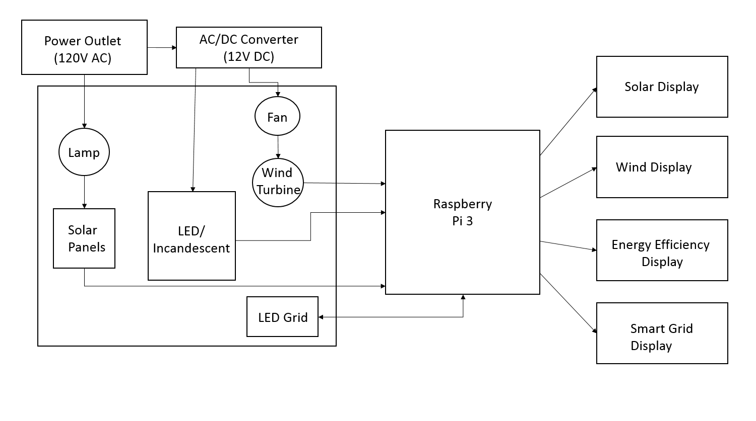

**Figure 1: System block diagram**

## User interface.

The majority of the user interface for this project is the buttons and interactive elements of each module. For the solar module, users can change the filters of light to simulate different weather conditions. For the wind module, users can change the wind turbine blades and the fan speed. For the energy efficiency module, users are able to toggle between using incandescent and LED light bulbs.

In the Smart Grid module, users can cause a blackout by disconnecting some transmission lines and restore the power by reconnecting the transmission lines. This module also has a touchscreen LCD that users are able to interact with. This display has two different screens: the first screen is the Sum Screen which consists of how the entire project (“city” of Boston) works together. As shown in Figure 2, Boston’s need, renewable contribution, and percent green are recorded on the Sum Screen. Each module contributes some green energy, so the renewable contribution data will change thus changing the percent the city is green. The second screen is the Smart Grid screen. As shown in Figure 3, the Smart Grid screen shows the total number of customers in the city, the total number of customers out of power due to the simulated blackout, and the time said blackout has lasted. Each of these screens has a button that allows the user to go back and forth between the two screens: on the Sum Screen, it is the Smart Grid button, and on the Smart Grid screen, it is the back button.

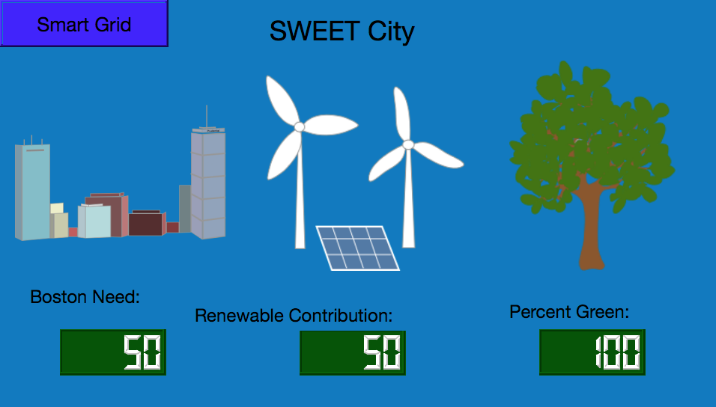

**Figure 2: Sum Screen GUI**

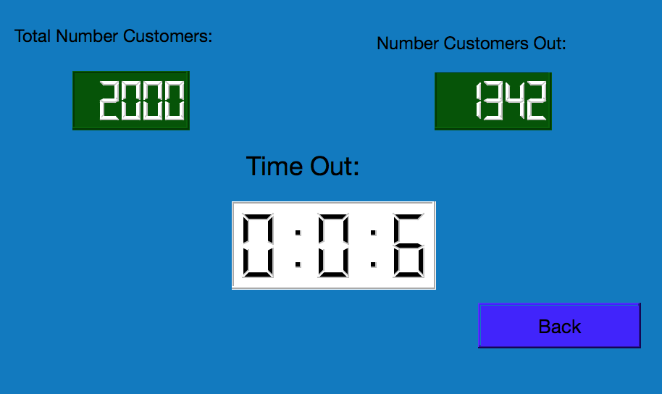

**Figure 3: Smart Grid GUI**

## Physical description

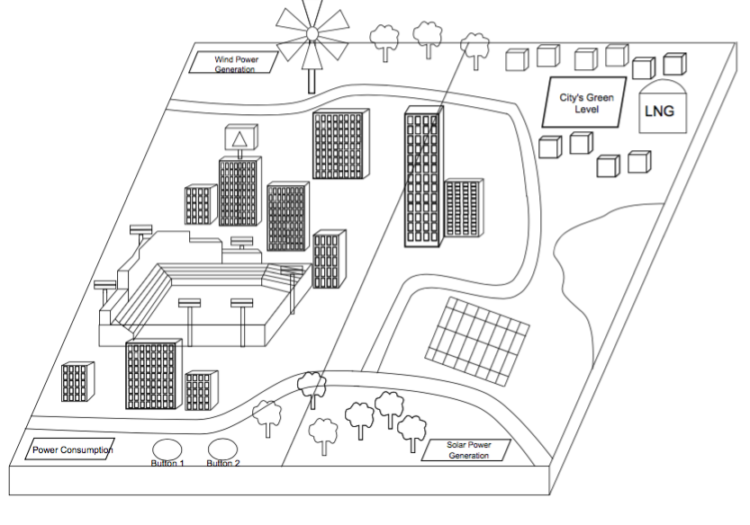

**Figure 4: Representation of what the project will look like upon completion**

## Installation, setup, and support

*2.4.1 Software*

Upon powering on the system, all of the Raspberry Pis will turn on. This will begin the booting process. Once they all boot up, they will automatically run the necessary software for each function. No further setup is required.

*2.4.2 Hardware*

The initial assembly of the hardware portion of this project consists of plugging the power cord into an outlet. After plugging in the power cord, everything should be powered on. All of the LCD screens should light up and be ready for use. Once all the LCDs are ready and all the Raspberry Pis are booted up, the project should be operational.

# Operation of the Project

## Operating Mode 1: Normal Operation

*3.1.1 Solar Module*

Normal operation of the solar module consists of variable power generation based on user input. A customer is able to switch between light filters which simulate different weather conditions. As the power generated varies, a visual load made of LEDs brightens or dims. The power generation is measured by a Raspberry Pi and is displayed on the module’s LCD.

To operate the solar module in the intended way, first, turn on the lamp using the black knob on the back. Slide the jeweler’s glass arrangement of light filters one by one in front of the lamp. As the filters change, the power output from the solar panels will increase or decrease and the LEDs on the LNG tank will brighten or dim, respectively. To account for the varying power generation, the power output display will also change.

*3.1.2 Wind Module*

Operation of the wind module, much like solar module, consists of variable power generation. A National Grid customer can switch out wind turbine blades with different aerodynamic traits. The power generated from the turbine powers an LED model of the Citgo sign. The LEDs will brighten or dim depending on the type of blades used.

To use the wind module, select a blade type and attach it to the turbine. Turn on the fan and the turbine will begin to spin. The turbine will then begin generating power and the Citgo sign will illuminate. This will directly affect the power generation display shown on the module’s LCD screen. Before changing to another blade type, turn off the fans and wait for the turbine to stop rotating. Change the blade, and repeat the original process.

*3.1.3 Energy Efficiency Module*

1. Set switch 1 to the “on” position. This supplies the module with power and the LCD displays power consumed depending on the switch 2 setting.
2. Switch 2 has two toggle settings: incandescent and LED. Toggle switch 2 to the incandescent setting to turn on the incandescent bulbs and display their power consumption on the module LCD.
3. While keeping switch 1 in the on position, toggle switch 2 to the LED setting. This turns off the incandescent bulbs and turns on the LEDs. The LED power consumption is displayed on the LCD.
4. Turn switch 1 back to the “off” position and both sets of lights are shut off. The power consumption display will show a value of 0.

*3.1.4 Smart Grid Module*

1. The LCD should be displaying the overall data for the project
2. When customer wants to start the Smart Grid display, press the Smart Grid button on the LCD screen. A new screen should show up with number of customers and a timer that should say zero
3. Once at the screen, the user can disconnect the transmission line and cause a blackout
4. After lights go out, the user can watch the Smart Grid program turn on 80% of the lights. While this happens, the number of customers out on the LCD screen changes and the timer records the length of the blackout
5. At any point, the user can reconnect the transmission line and power will be restored to all the houses
   1. If the user never reconnects the transmission line, the remaining 20 percent of houses will not regain power (these need to be manually restored as that is how the actual Smart Grid pilot program works)

## Safety Issues

The SWEET City was designed as a safe interactive exhibit. To combat any safety issues, voltage is limited to less than 15V DC throughout the entire exhibit and current was limited to the microamp level in all modules except for the energy efficiency module. The energy efficiency module uses incandescent light bulbs, which require relatively high current to light. To keep a safe design for this module, there are very few exposed wires. The minor exposure at bulb contact points are heavily insulated to keep a low level of injury possibility.

Other main safety issues include moving fan blades and the spinning wind turbine. The fan blades will be covered to keep children from getting their fingers caught in the blades. The turbine blades, however, are accessible and cannot be covered due to the nature of the module. The relatively low radial speed of the turbine blades should keep any injury potential to a minimum.

# Technical Background

***4.1 Solar Module***

The solar module includes a lamp as a light source, two series wired solar panels, a voltage divider for Raspberry Pi measurements, and a current limited visual load. When wired in series, the solar panels output a maximum of 12V. The Raspberry Pi, however, can only take 3.3V per pin. As shown in figure 5, to step down the high output voltage, a 5.1 to 1 ratio voltage divider is used. The lowered voltage is measured by the Raspberry Pi and then scaled up by the factor it was stepped down by.

Current is calculated by finding a linear load line relative to voltage. A set of data

points were collected and the equation of the load line is used to calculate current. The measured voltage and calculated current are used to find power supplied to the load. The power is scaled to a realistic city level and is displayed to the module’s LCD screen.

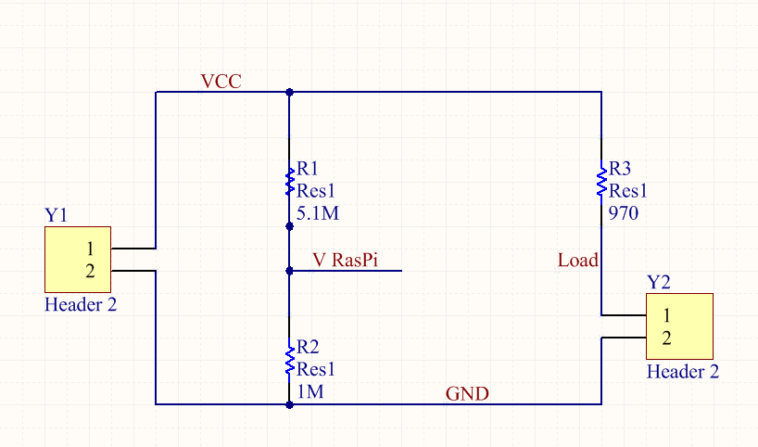

**Figure 5: Circuit diagram for Solar Module (similar to Wind module circuit)**

***4.2 Wind Module***

The wind module uses a set of three pwm computer fans, powered by a 12V DC source, to operate a wind turbine. As the turbine blades spin, a DC generator produces a small amount of DC power. The voltage produced is stepped up to useable levels with an inverting operational amplifier configuration. The stepped up voltage supplies a current limited visual load. Current and voltage are measured with the same process used in the solar module. The acquired data is then scaled to fit a city value and is displayed on the module’s LCD.

***4.3 Energy Efficiency Module***

The energy efficiency module uses user controlled switches as well as n and p type transistors to switch between incandescent and LED lighting. National Grid customers are able to flip a switch that powers the entire circuit. Once switch 1 is set to the “on” position, closing the circuit, a set of incandescent light bulbs turn on. A second switch controls the bulb type. When switch 2 is flipped, the circuit transitions bulb types. If the incandescent bulbs were originally lit, they shut off and the LEDs turn on.

The circuit operates on a fixed 12V DC source, defined as P1 in figure 6. In operating mode 0, the first switch, S1, is in the “off” position. This opens the entire circuit and cuts off the supply. No bulbs are lit in this mode.

Operating mode 1 has switch 1 in the “on” position, which powers the circuit. Switch 2, S2, is toggled to the left which indicates incandescent light bulbs. This grounds the gate of a PMOS transistor, turning on the incandescent load. With the switch in this position, the base of an NPN transistor is grounded. This keeps the transistor off and no current is supplied to the LED load.

When switch 2 is toggled to the right position, the gate of the PMOS transistor is brought high, turning off the transistor and the incandescent load. The base of NPN transistor goes high, turning it on and supplying current to the LED load.

A Raspberry Pi microcontroller takes the current and voltage values of each load type. The power values are calculated and sent to the module’s LCD. Customers are able to see the dramatic difference in power consumption when toggling between the two bulb types.

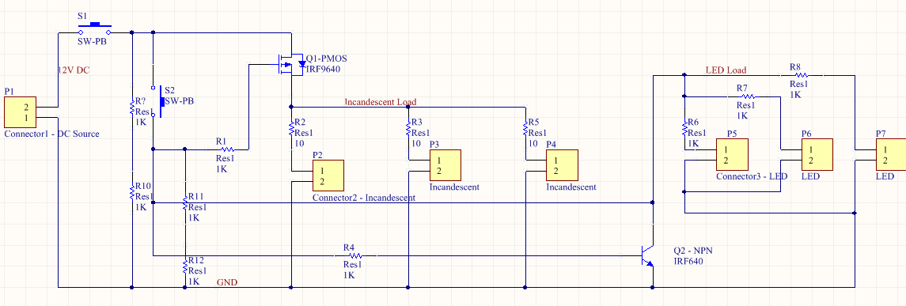**Figure 6: Circuit design for Energy Efficiency Module**

***4.4 Smart Grid Module***

The final module, smart grid, simulates blackout response in the city of Boston. The module is divided into four quadrants of LEDs. A single quadrant is shown in figure 7. Each quadrant has its own voltage source, a 3.3V DC Raspberry Pi pin. This source voltage is shown as the P6 connector in figure 7. Every LED in the circuit has a 10 ohm current limiting resistor. This keeps the LEDs at a reasonable brightness, while making sure they do not burn out. The LEDs in each quadrant are wired in parallel. If one LED happens to burn out, the quadrant will still function.

The user is able to trigger a blackout and start the smart grid demonstration by opening a transmission line, which cuts a signal going to the Raspberry Pi. Once the input pin of the Pi is low, a blackout occurs and all quadrants go dark. A python code executes and restores power to three of the four quadrants, one by one, at a randomized time interval. The fourth quadrant has power restored to it when the user manually replaces the opened transmission line.

The module includes a display that shows time it took to restore power, the number of users without power, and the total number of uses. A second display gives an overview of the details of the exhibit. The displayed statistics include “percent green,” Boston’s total energy need, and the renewable contribution to the city.

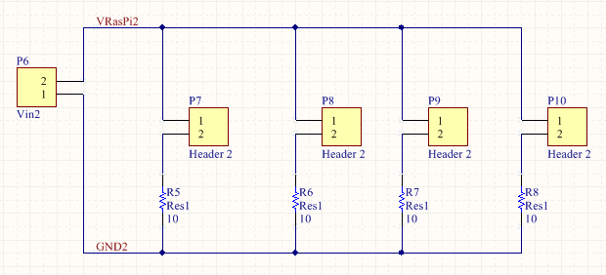

**Figure 7: Circuit Design for a single quadrant of the Smart Grid Module**

***4.5 Module Displays***

For the Solar, Wind and Energy Efficiency modules, 16x2 LCD displays are utilized to present the specific data. This is done using 4 data bus lines connected between the Raspberry Pi and the display. A program is written that will use a library from Adafruit that provides functionality for LCD displays. The library allows the user to choose which pins to use as the data lines when the LCD object is created within our code. Then when the display is written, the function will take in the input and send it through the data lines so that it may appear on the screen.

For the Smart Grid module, a 3.5” LCD touchscreen is used to present Smart Grid data and total project data. The graphics for the GUI were made using Sketch and then imported into Qt Designer in order to create and program the GUI. After programming the functions for the buttons and values using python, the Smart Grid code was integrated with the GUI code. This was then run on the Raspberry Pi so that the data is displayed on the screen while the Smart Grid pilot program runs.

# Cost Breakdown

|  |  |  |  |  |
| --- | --- | --- | --- | --- |
| Project Costs for Production of Beta Version (Next Unit after Prototype) | | | | |
| Item | Quantity | Description | Unit Cost | Extended Cost |
| 1 | 4 | Printed Circuit Board | $33 | $132 |
| 2 | 3 | Raspberry Pi 3 | $40 | $120 |
| 3 | 4 | Aluminum Extrusion | $75 | $300 |
| 4 | 3 | 16 x 2 LCD Display | $6 | $18 |
| 5 | 1 | 3.5” LCD Display | $22 | $22 |
| 6 | N/A | Miscellaneous Building and Construction Supplies | $150 | $150 |
| 7 | 2 | Solar Panel | $7.50 | $15 |
| 8 | 1 | Generator | $5.15 | $5.15 |
| 9 | 1 | Lamp | $23.40 | $23.40 |
| 10 | 2 | Fan | $12 | $24 |
| 11 | 6 | Light Filters | $2 | $12 |
| 12 | 3 | microSD Card | $11.46 | $34.38 |
| 13 | 2 | microUSB Cable | $7.33 | $14.66 |
| Beta Version-Total Cost | | | | $870.59 |

**Table 1: Cost of Beta Version**

# Appendices

## Appendix A - Specifications

|  |  |
| --- | --- |
| **Requirement** | **Result** |
| Displays | 4 module displays and a project summary display. |
| Solar Module | Power generated varies with user interaction. Visual load brightens and dims with included light filters. Power generation is displayed. |
| Wind Module | Generates power with a small DC generator. Power generated varies with turbine blade type. Visual load brightens and dims when blades are changed. Power generation is displayed. |
| Energy Efficiency Module | Switches between LED and incandescent bulbs. Power consumption is displayed. |
| Smart Grid Module | Simulates blackout response when triggered by user. Time to restore power and number of users offline is displayed. |
| Transportation | Two 36” x 18” pieces, totalling 1 sq. yard. Weight ~35lbs. |
| Safety | Voltage held under 15V, no loose or excessive wires. Current is kept in the microamp level aside from energy efficiency module. EE module has heavy insulation at exposed contact points. |
| Theme | Boston themed - Citgo Sign, Prudential Center, Rainbow Swash LNG tank, Fenway Park. |
| Branding | National Grid logo and color scheme presented in all modules. |

**Table 2: Specifications Table**

## Appendix B – Team Information

|  |  |  |
| --- | --- | --- |
| **Team Member** | **E-mail** | **Reason for Choosing Project** |
| Jessica Cadreau | jcadreau@bu.edu | I chose this project because I am very interested in renewable energy. All of my family members work in this sector and I would like to do the same. I am thinking about working for a utility company with my sister and my brother when I graduate and I hoped this project would expand my understanding of this field. |
| Jennifer Fong | jkfong@bu.edu | This project was particularly interesting to me because over the Summer, I had an internship at a local utility in Hawaii. Through this internship, I learned about the power industry and what utilities do for their customers. Because of this, I wanted to learn even more and also educate the public about the power industry. |
| Cameron Graves | cagraves@bu.edu | I found this project intriguing due to my interest in renewable energy and large scale power systems. I plan pursue a career with a utility company in the Boston area and saw this as a great educational opportunity. |
| Makenna Hart | hartm04@bu.edu | I chose this project because I am very interested in how a grid system in a city works and how all of the components work together. I hope to have a career in the power industry and help everyone learn about more efficient ways to both consume and produce energy. |
| Steven Li | listeven@bu.edu | I was interested in this project because since high school, I was always curious about the conditions of our environment and was concerned about sustainability. I have taken classes at BU to learn more about the different technologies that are geared towards a more sustainable future and I liked the idea of educating others on these topics. |

**Table 3: Team Information**